Documentatie exercitii fizice + teste pentru stabilirea abilitatilor jucatorului

1. Modul de executare a exercitiilor fizice:

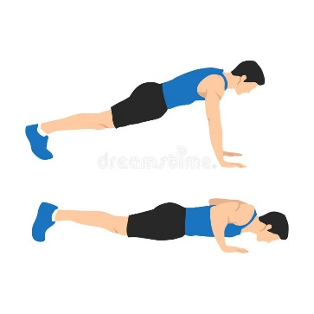**-flotare:**

*mod de executie:

*“From a prone position, the hands are placed under the shoulders with the elbows extended. Keeping the back and legs straight with the toes touching the ground.*

*The body is lowered until the upper arm is parallel to the ground.*

*Then reverse the movement and raise the body until arm is extended.”*

*metrici:

Sursa: <https://www.physio-pedia.com/Pushups>

https://strengthlevel.com/strength-standards/push-ups/kg

**-genoflexiune:**

*mod de executie:

*“Start with feet placed in subjects preferred position (to avoid extra stress upon the subject and to increase the external validity towards training). Shoulders at 90 degree flexion.*

*The subject keeps their chest up, engaging abdominals, and shifts weight onto your heels as they push hips back into a sitting position.*

*The subject flexes the knees down to a depth where the hip crease drops below the patella, keeping knees over, but not beyond, toes.*

*Subject exhales and returns back up to the starting position. ”*

*metrici:

*“Male squat standards vary based on training experience and goals, but generally, an average male lifter can squat about 1.5 times their body weight. Beginners might lift below their body weight, while elite lifters can reach double their body weight or more. For muscle growth, aim for 8-12 reps with 65-85% of your one-rep max. Strength-focused lifters often use heavier weights for 6-8 reps.”*

*Sursa:* <https://www.physio-pedia.com/Squat_Exercise>

*https://www.endomondo.com/training/how-much-should-you-be-able-to-squat*

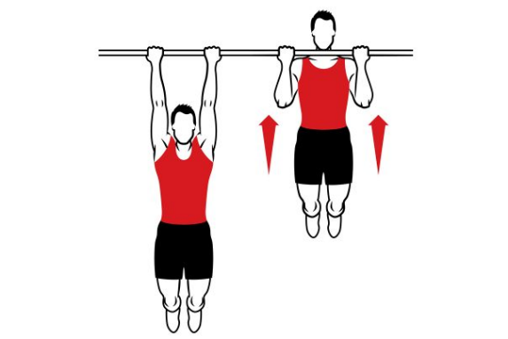**-tractiune:**

*mod de executie:

*“The arms should be straight at the start of each rep but not a dead hang.*

*Keep your glutes and abdominals tight. This helps you stop swinging.*

*For chin-ups (palms facing you), try one hand space inside of a shoulder-width grip. For pull-ups (palms away from you), try one to two hand spaces outside of shoulder-width.”*

*metrici:

*Sursa:* https://www.physio-pedia.com/Chin_Up_Exercise

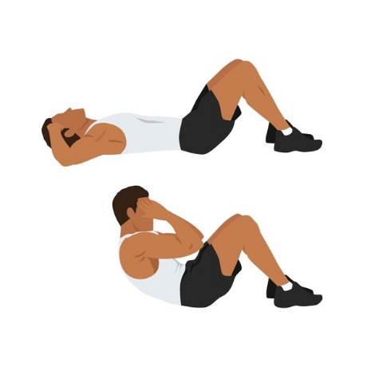**-abdomen:**

*mod de executie:

*“Start in supine with with knees bent and feet comfortably flat on the floor;*

*Curl up your head and bring your chin towards your chest, fixing your neck position*

*Hands placed behind ears with elbows pointing out to the side.*

*Focus on abdominals, curling upper back off the floor, not moving any other body part, keeping arms, shoulders, neck and legs relaxed as the abs pull you up. If the movement is performed correctly, the head and arms will curl up as one unit with your shoulders;*

*Stop when the upper back is off the floor.*

*Pause for one count at the top.*

*Slowly lower the upper back down to the floor”*

*metrici:

1. For active individuals the fastest cadence is 1 repetition/1 s that could be used,
2. For other less active populations a slower curl-up speed is recommended to decrease the risk of injury and allow for motor control.

*Sursa:* https://www.physio-pedia.com/Curl-ups

1. Teste pentru stabilirea abilitatilor jucatorului

**-10m sprint:** sprint de 10 metri pentru a putea evalua acceleratia initiala

barem:

*“Elite male sprinters can complete the 10 m sprint in around 1.6-1.8 seconds.*

*Elite female sprinters can complete the 10 m sprint in around 1.8-2.0 seconds.*

*Well-trained male athletes can complete the 10 m sprint in around 1.9-2.1 seconds.*

*Well-trained female athletes can complete the 10 m sprint in around 2.1-2.3 seconds.*

*Average males can complete the 10 m sprint in around 2.4-2.8 seconds.*

*Average females can complete the 10 m sprint in around 2.7-3.1 seconds.”*

*Sursa: https://www.matassessment.com/blog/10m-sprint-test*

**-50m sprint:** sprint de 50 metri pentru a putea evalua acceleratia si viteza maxima pe care o dezvolta jucatorul

barem:

Timpul mediu pe 50 m sprint la jucătorii testați a fost de aproximativ 6,40 ± 0,30 secunde.  
Sportivii au atins viteza maximă între 30–40 m de alergare.

<https://www.cantemircml.ro/docs/ed_fizica_bareme_probe.pdf> (barem domeniu militar)  
  
*Sursa: https://pmc.ncbi.nlm.nih.gov/articles/PMC8008306/*

**-saritura in lungime:**

porneste din pozitie dreapta cu picioarele la latimea umerilor, coboara in semi-genuflexiune, impinge exploziv si balanseaza bratele inainte pentru a sari cat mai departe, aterizand stabil pe ambele picioare

barem:

*Sursa:* [*https://www.topendsports.com/testing/tests/longjump.htm*](https://www.topendsports.com/testing/tests/longjump.htm)

*www.brianmac.co.uk/stndjump.htm*

**-saritura de pe loc pe verticala:**

saritura de pe loc, cu bratele pe langa corp, spatele drept, privirea inainte; se coboara intr-o semigenoflexiune, se imping soldurile usor inapoi; impingerea exploziva in podea intinzand gleznele, genunghii si soldurile intr-o miscare fluida; revenirea pe sol se face cu ambele picioare simultan, cu genunchii usor indoiti pentru absorbirea socului.

barem:

*Sursa: https://www.physio-pedia.com/Vertical_Jump_Test*

**-20 feet kick ups:**

stai drept, loveste mingea alternativ cu picioarele, mentinand controlul, folosind interiorul sau varful piciorului, fara sa cada mingea la sol

barem:

//subiectiv, trebuie sa ma gandesc

**-5-0-5:**

atletul pleaca spre un punct, schimba directia 180 de grade, si revine; pentru a evalua abilitatea de a frana si redirectiona viteza.

barem:

*Sursa: https://www.philplisky.com/blog/505-agility-test*

**-back sprint**

**//de completat**